PLANT DISEASE RECOGNITION PROGRESS REPORT
Ülke Eren Aktaş-21290742
Kadir Can Köse-20290355
Ahmet Hakan Aydoğan-17290084

Problem to be Addressed
Our topic is guessing whether a plant is sick or not. In this case, our program scans pictures of plants and makes a distinction about whether the plant is sick or not. Only some of the living things on Earth can express themselves and give us information about their health. Plants, however, have a different way of telling us about their health. Predicting whether a plant is healthy or unhealthy is a process based on observations and scientific methods provided by nature. As the natural order works as a system, plants are faced with some diseases that humans cannot understand or distinguish. Unless this situation is prevented, the plant dies much faster than its lifespan. In order to prevent such situations, it is very important and interesting to predict whether a plant is sick or not, because a plant's illness is caused by a combination of multiple factors such as its environment, genetic structure, maintenance conditions, etc. At the same time, when dealing with a large community of plants, some symptoms of plant disease can be overlooked because they are so small, and if they are not avoided, worse consequences can occur. Predicting the health of plants is not limited to observations, but also takes advantage of the possibilities offered by technology. Thanks to advances in technology, especially in artificial intelligence and image analysis, we can make more precise and faster predictions about the health of plants. Scanning images of a plant and extracting information on leaf color, shape, growth rate and other characteristics can provide valuable clues about its health. Given the complexity of factors affecting a plant's health, various data sources must be combined to improve the accuracy of these predictions. At the same time, when a plant is sick, it does not only give us information about the condition of the plant. It also gives us feedback that there may be a problem in one of the multiple environmental factors mentioned above.

In conclusion, making predictions about the health of plants is part of living in harmony with nature and ensuring the sustainability of ecosystems. These predictions require a combination of knowledge, observation and scientific methods and should include the health of the plants themselves as well as their environment and the overall ecosystem health.

Related Works

A Plant Disease Recognition Method Based on Fusion of Images and Graph Structure Text^{[1]}
By combining image and textual data for improved accuracy, the study proposed a fusion approach to address deficiencies in disease image recognition models. The method focused on tomato and cucumber diseases by integrating image features across multiple granularities and textual disease descriptions using a graph-based neural network. The resulting model achieved impressive recognition accuracy, with figures of 97.62% for overall accuracy, 92.81% for precision, 98.54% for sensitivity, and 93.57% for specificity. This inventive fusion model dramatically improved disease identification. It also presents a promising path for integrating a variety of data types into recognition systems.

Deep Learning for Image-Based Plant Disease Detection^{[2]}
A deep convolutional neural network was trained on a public dataset of 54,306 images of diseased and healthy plant leaves, identifying 14 crop species and 26 diseases. The model achieved an accuracy of 99.35% on a test set, demonstrating the feasibility of this approach on a global scale.

Plant Disease Recognition Based On Plant Leaf Image^{[3]}
The disease recognition method involves segmenting disease leaf images to obtain spot images before extracting recognition features. The process uses threshold segmentation, removing small bad regions and stems, and cropping the leaf area. This color-pixel segmentation method is suitable for an interactive application. The diseased region is extracted, and the plant disease is graded by calculating the quotient of disease spot and leaf areas.

Dataset and the Previous Results
This dataset focuses on the identification and classification of diseases in plant leaves based on visual characteristics. It comprises images of leaves categorized into three distinct classes:

Healthy: Leaves free from any visible signs of disease, exhibiting their normal color and texture.
Powdery: Leaves affected by powdery mildew, characterized by a white or gray powdery coating on the surface.
Rust: Leaves infected with rust fungi, displaying reddish-brown or yellow spots and pustules.

The dataset is further divided into three separate subsets:
Train: Used to train machine learning models for disease classification.
Validate: Used to evaluate the performance of the trained models on unseen data and adjust hyperparameters.
Test: Used to provide a final assessment of the model's generalizability on new data.

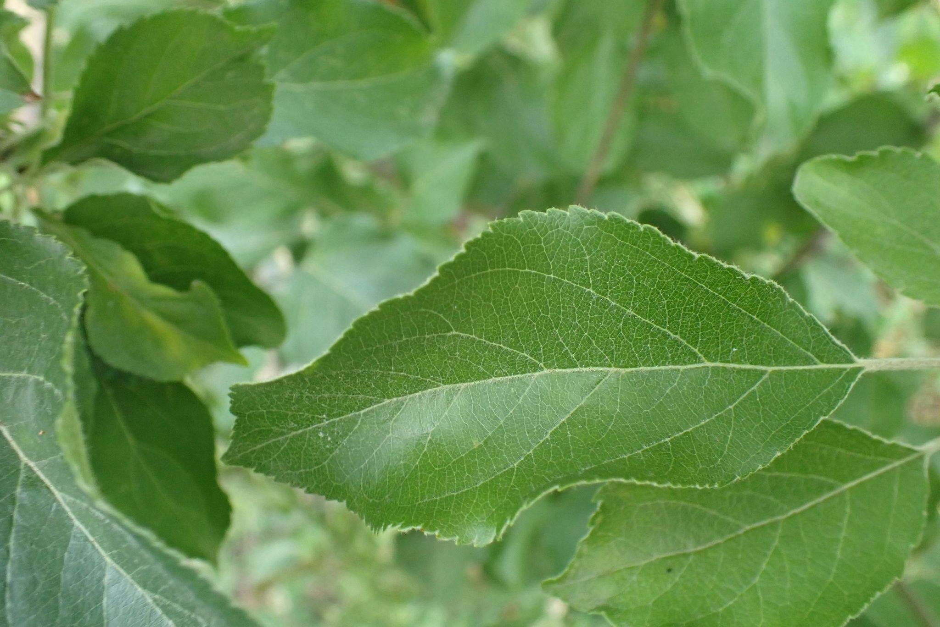
Healthy
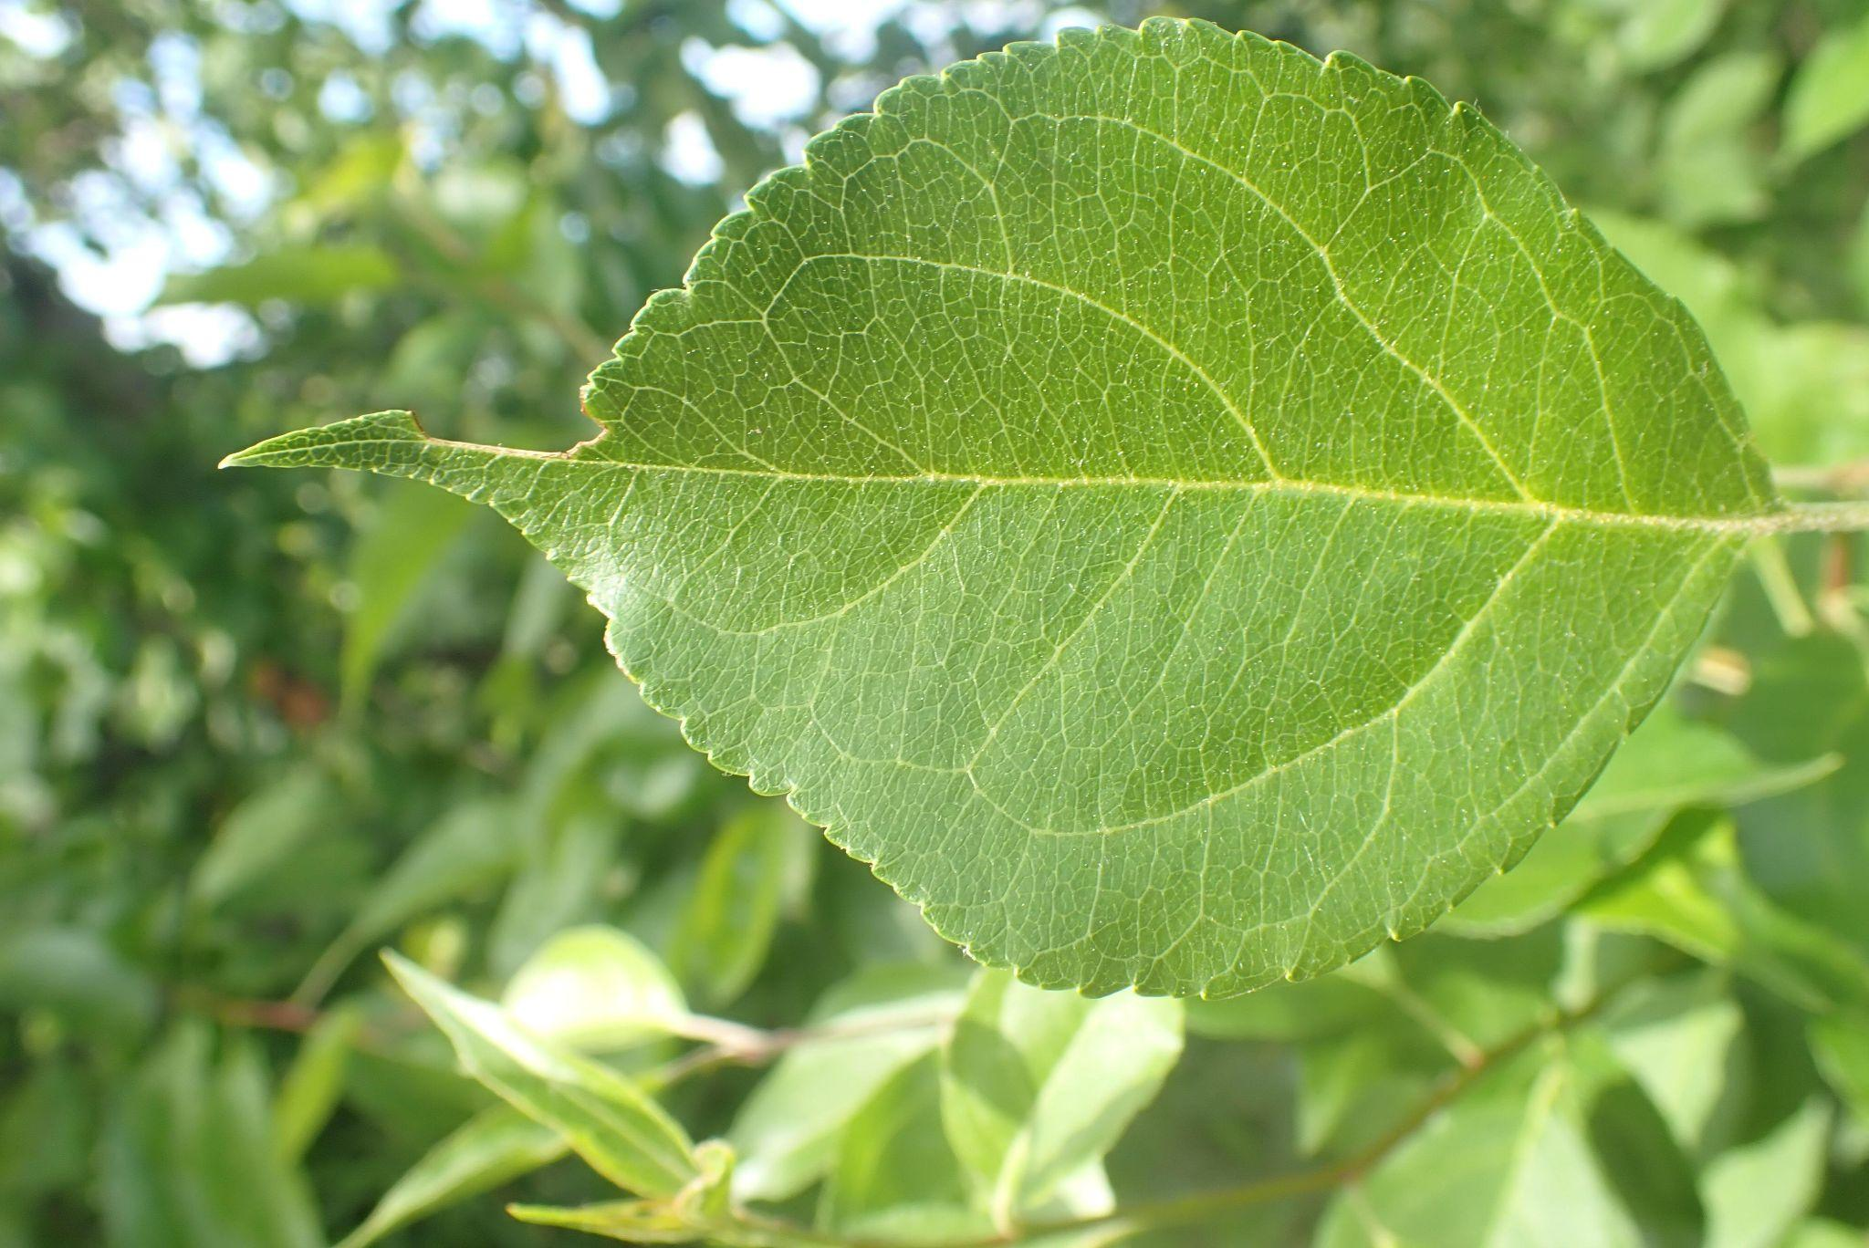
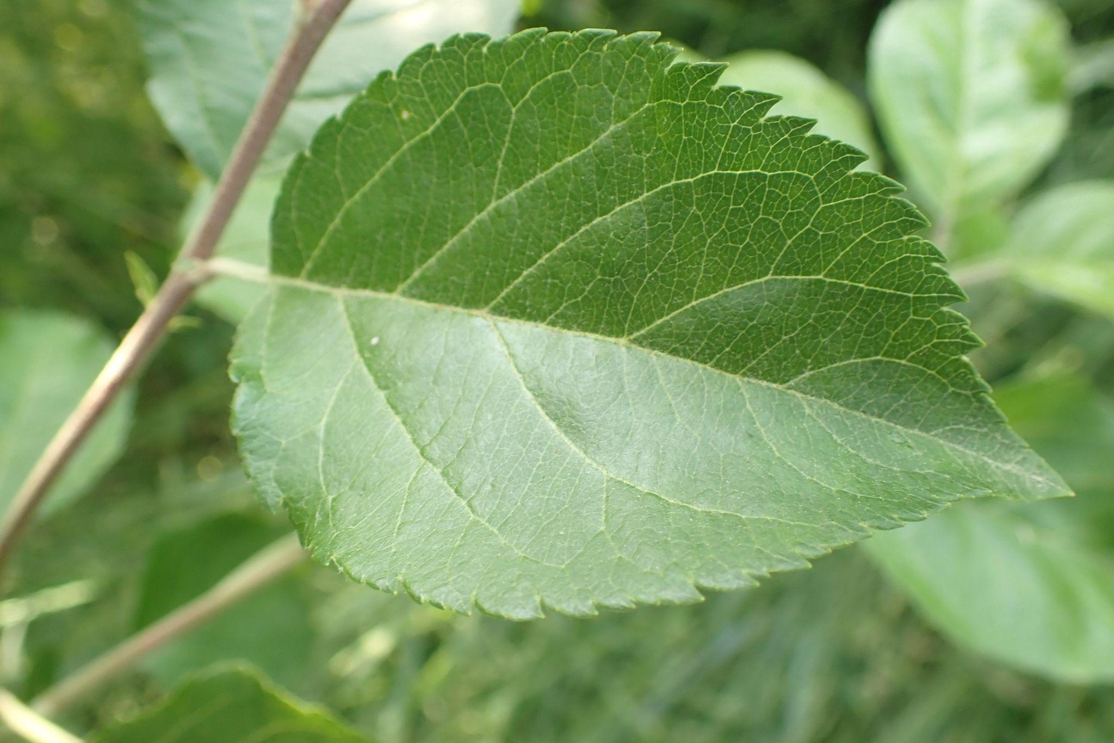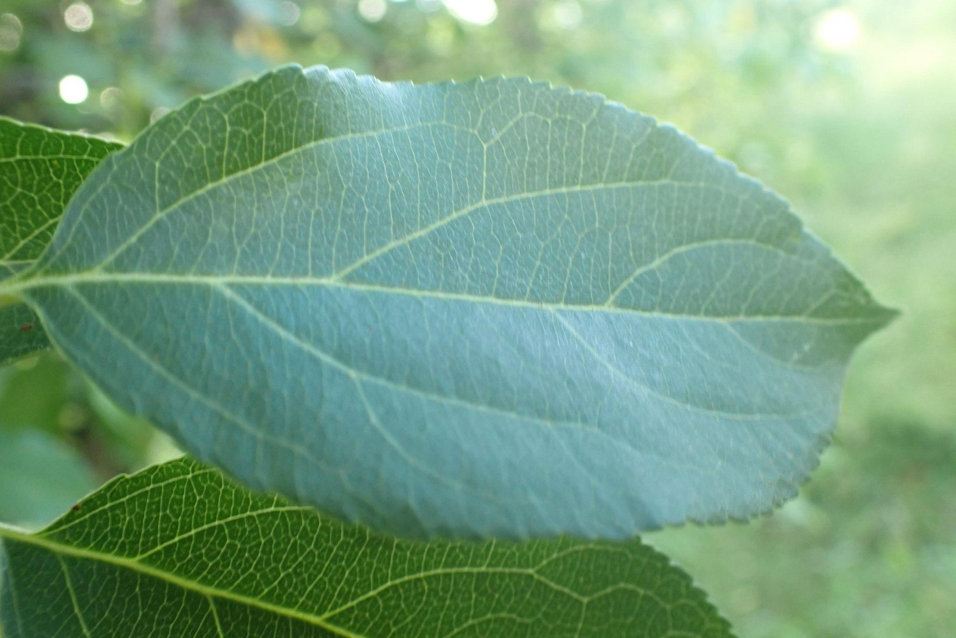

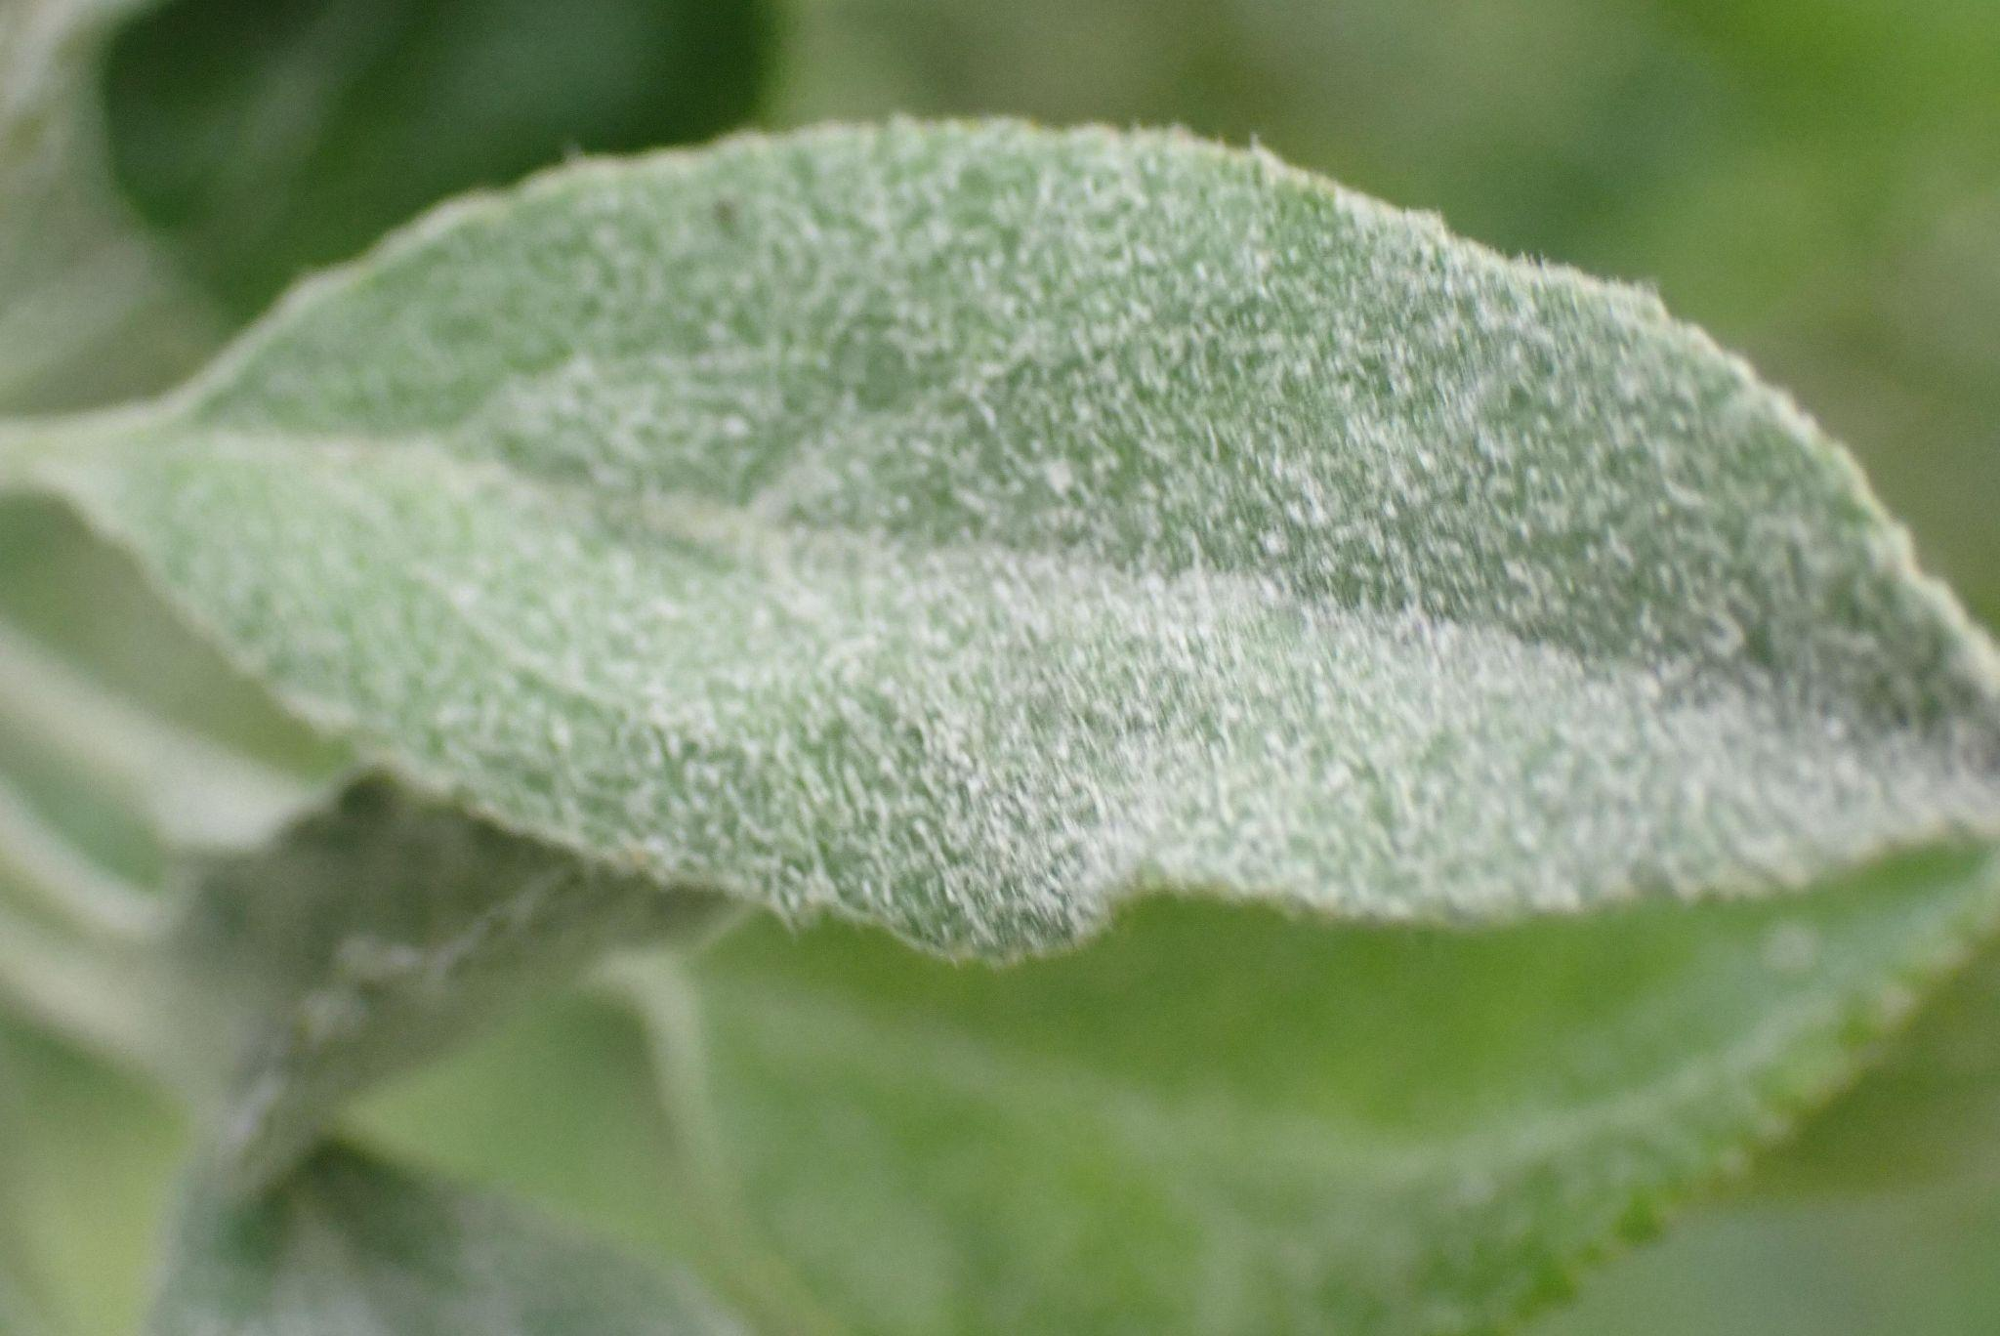
Powdery
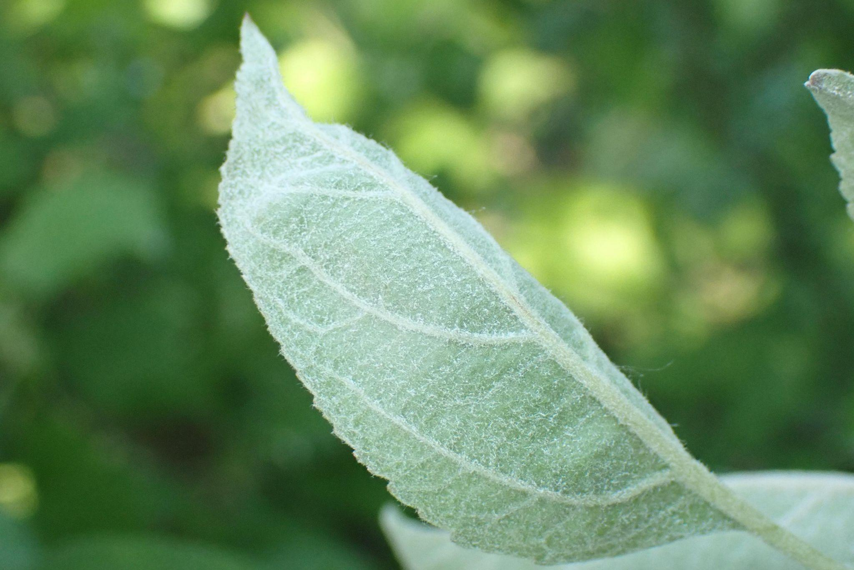
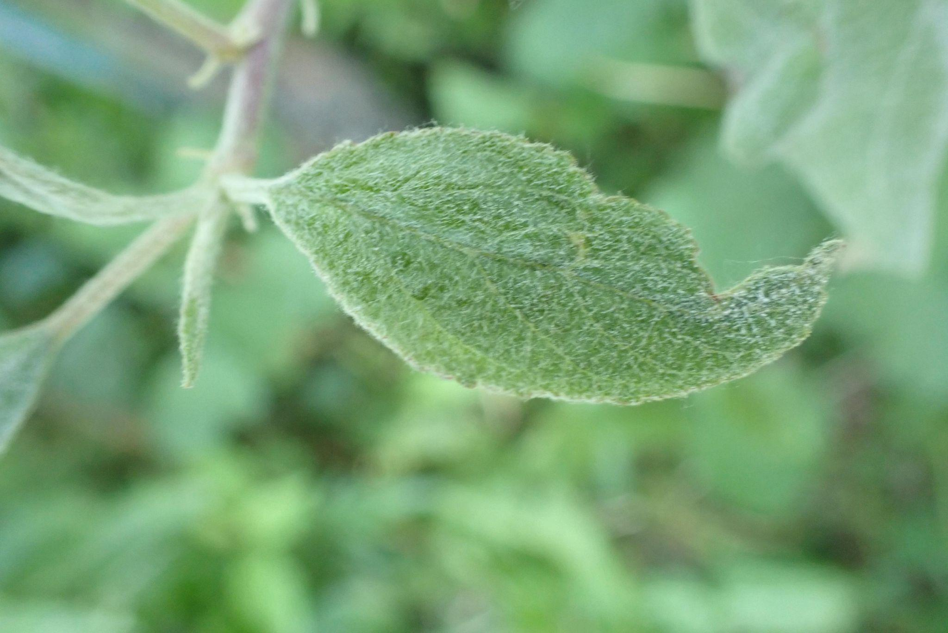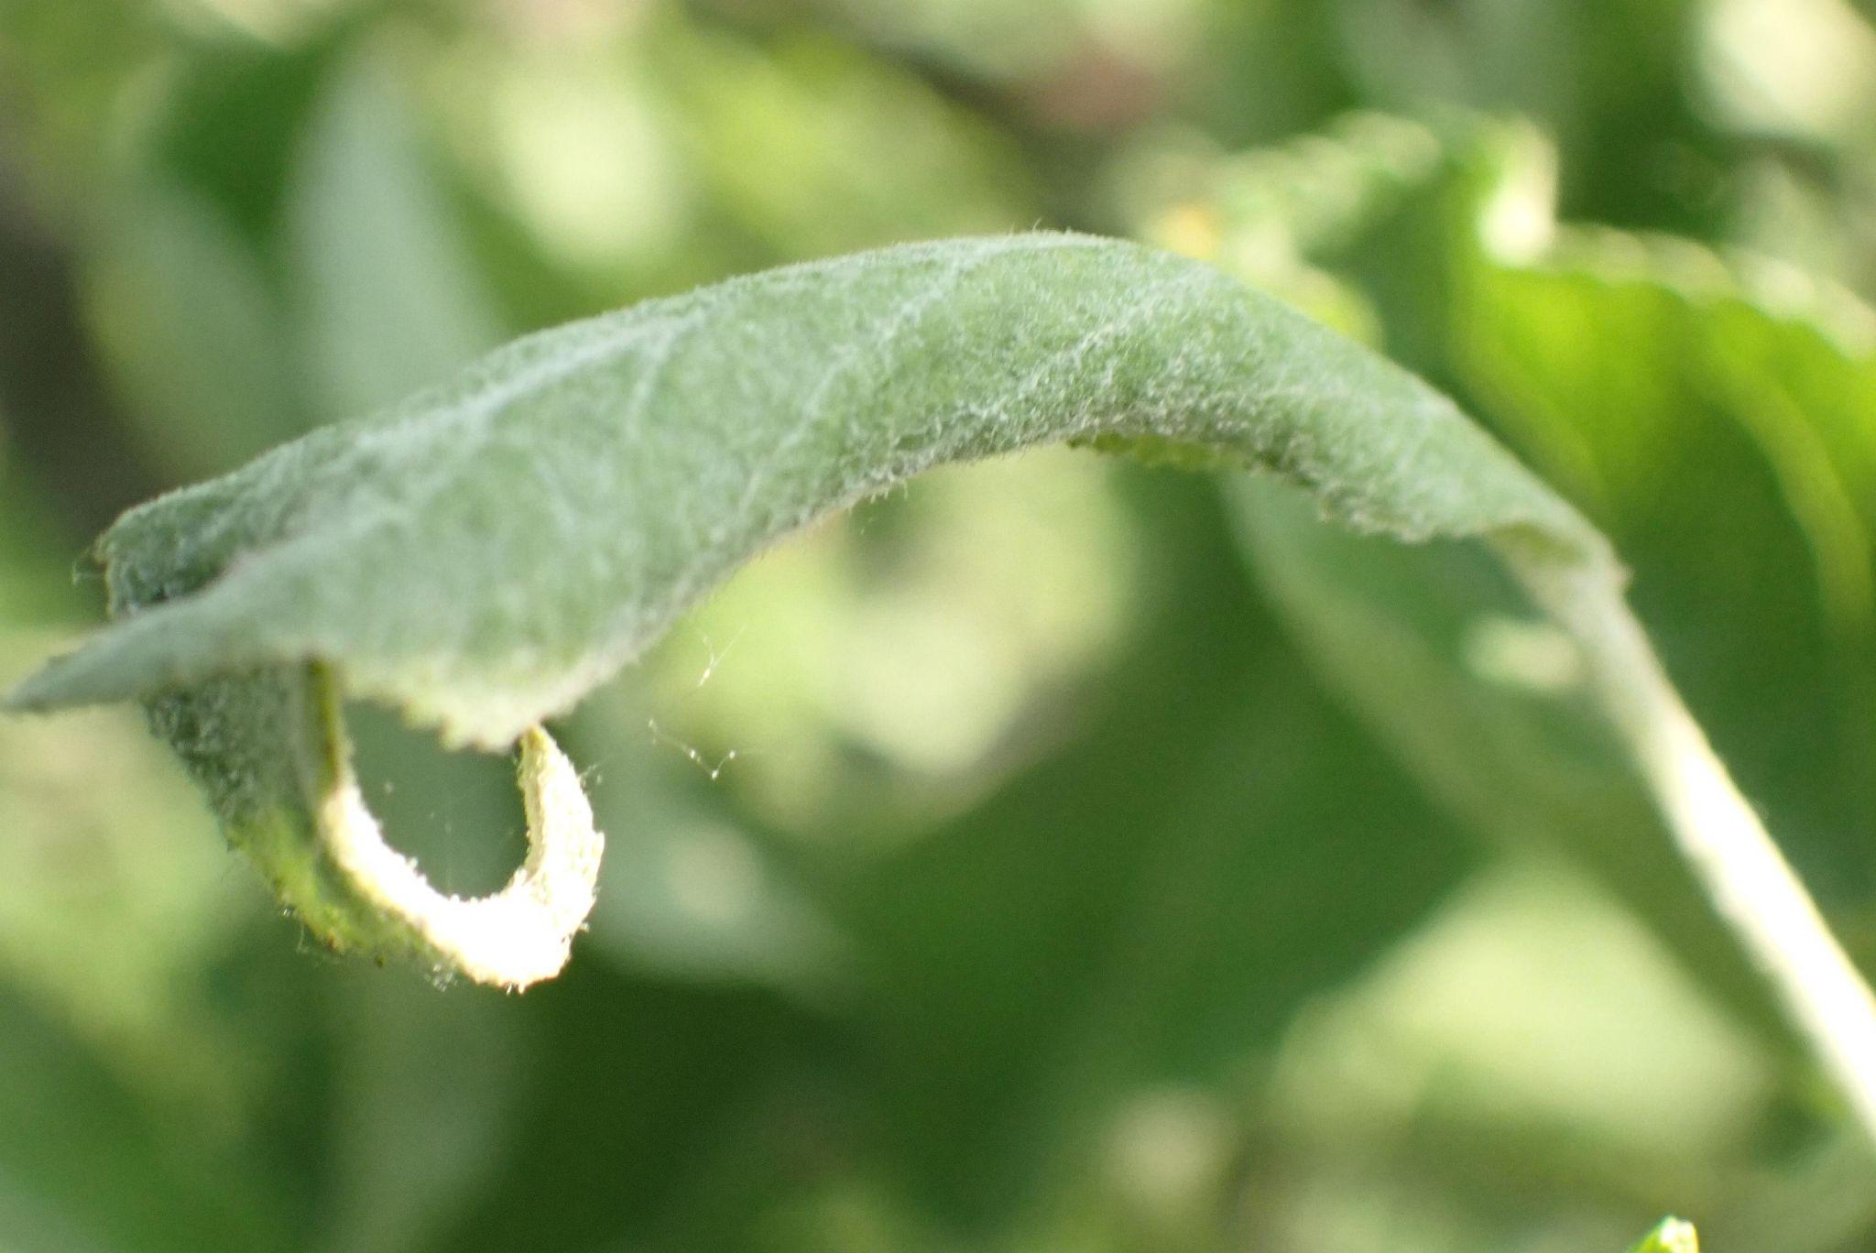

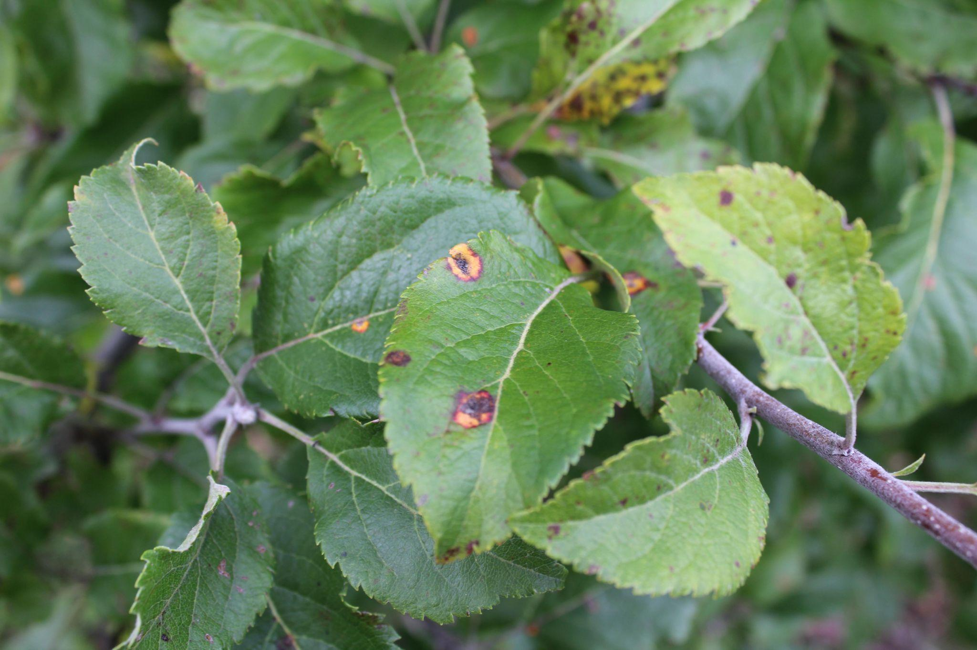
Rust
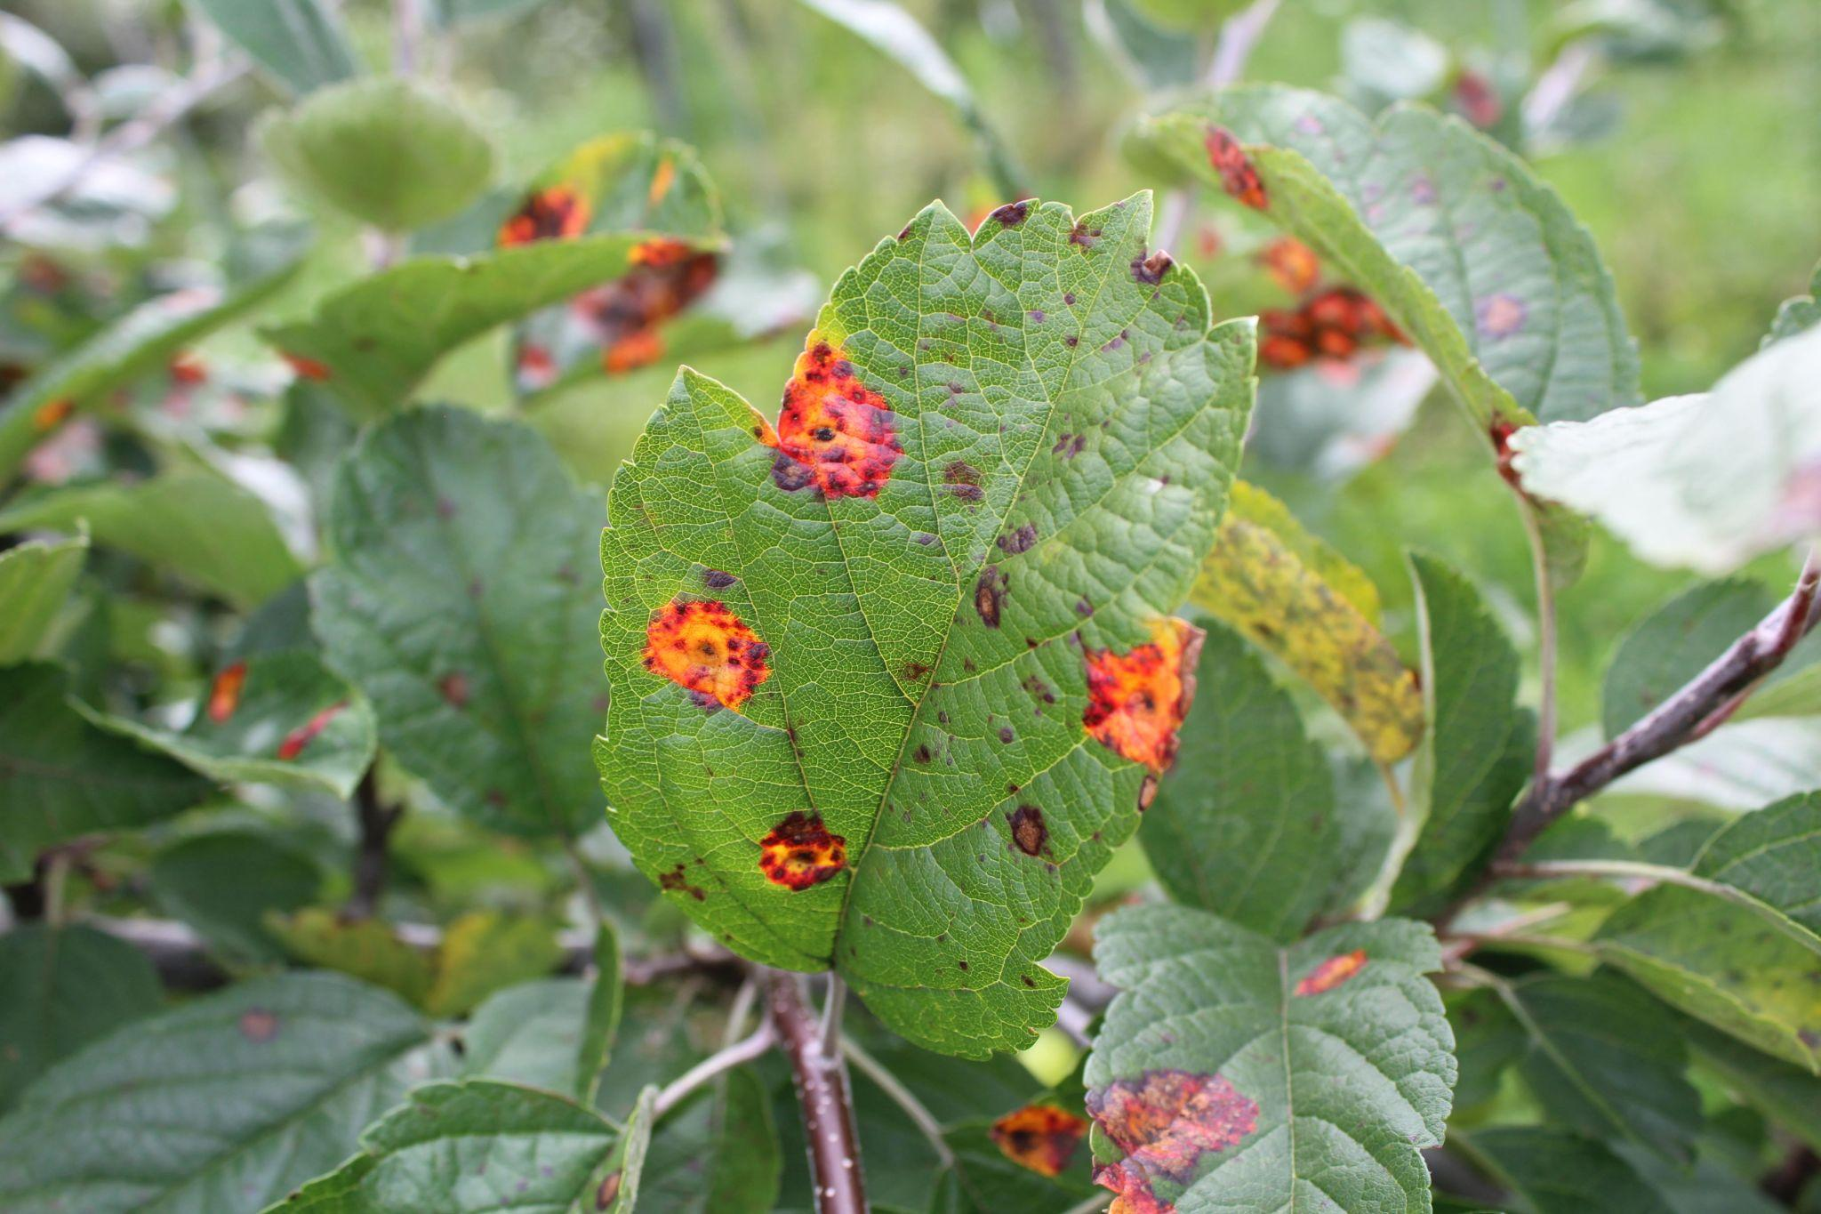
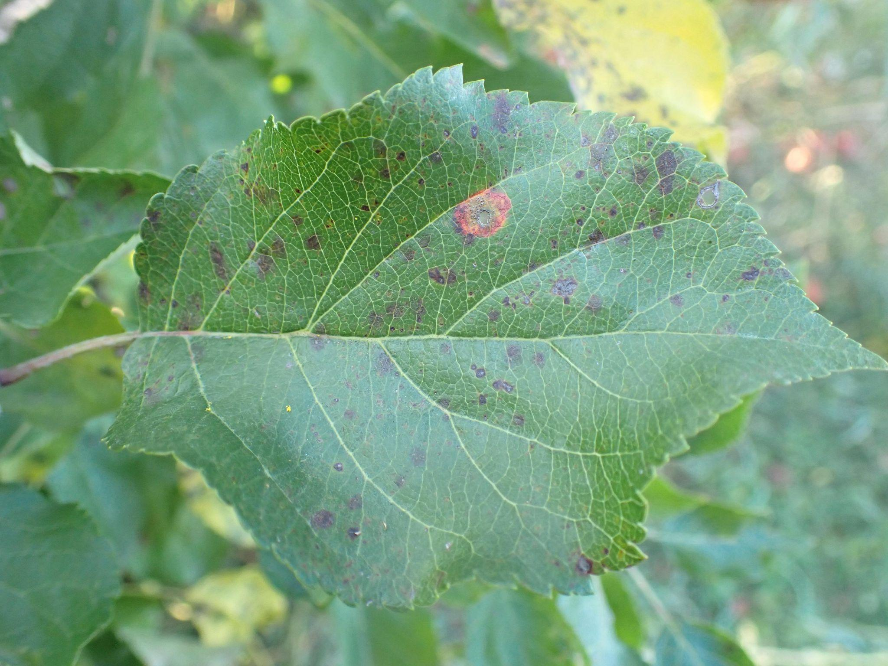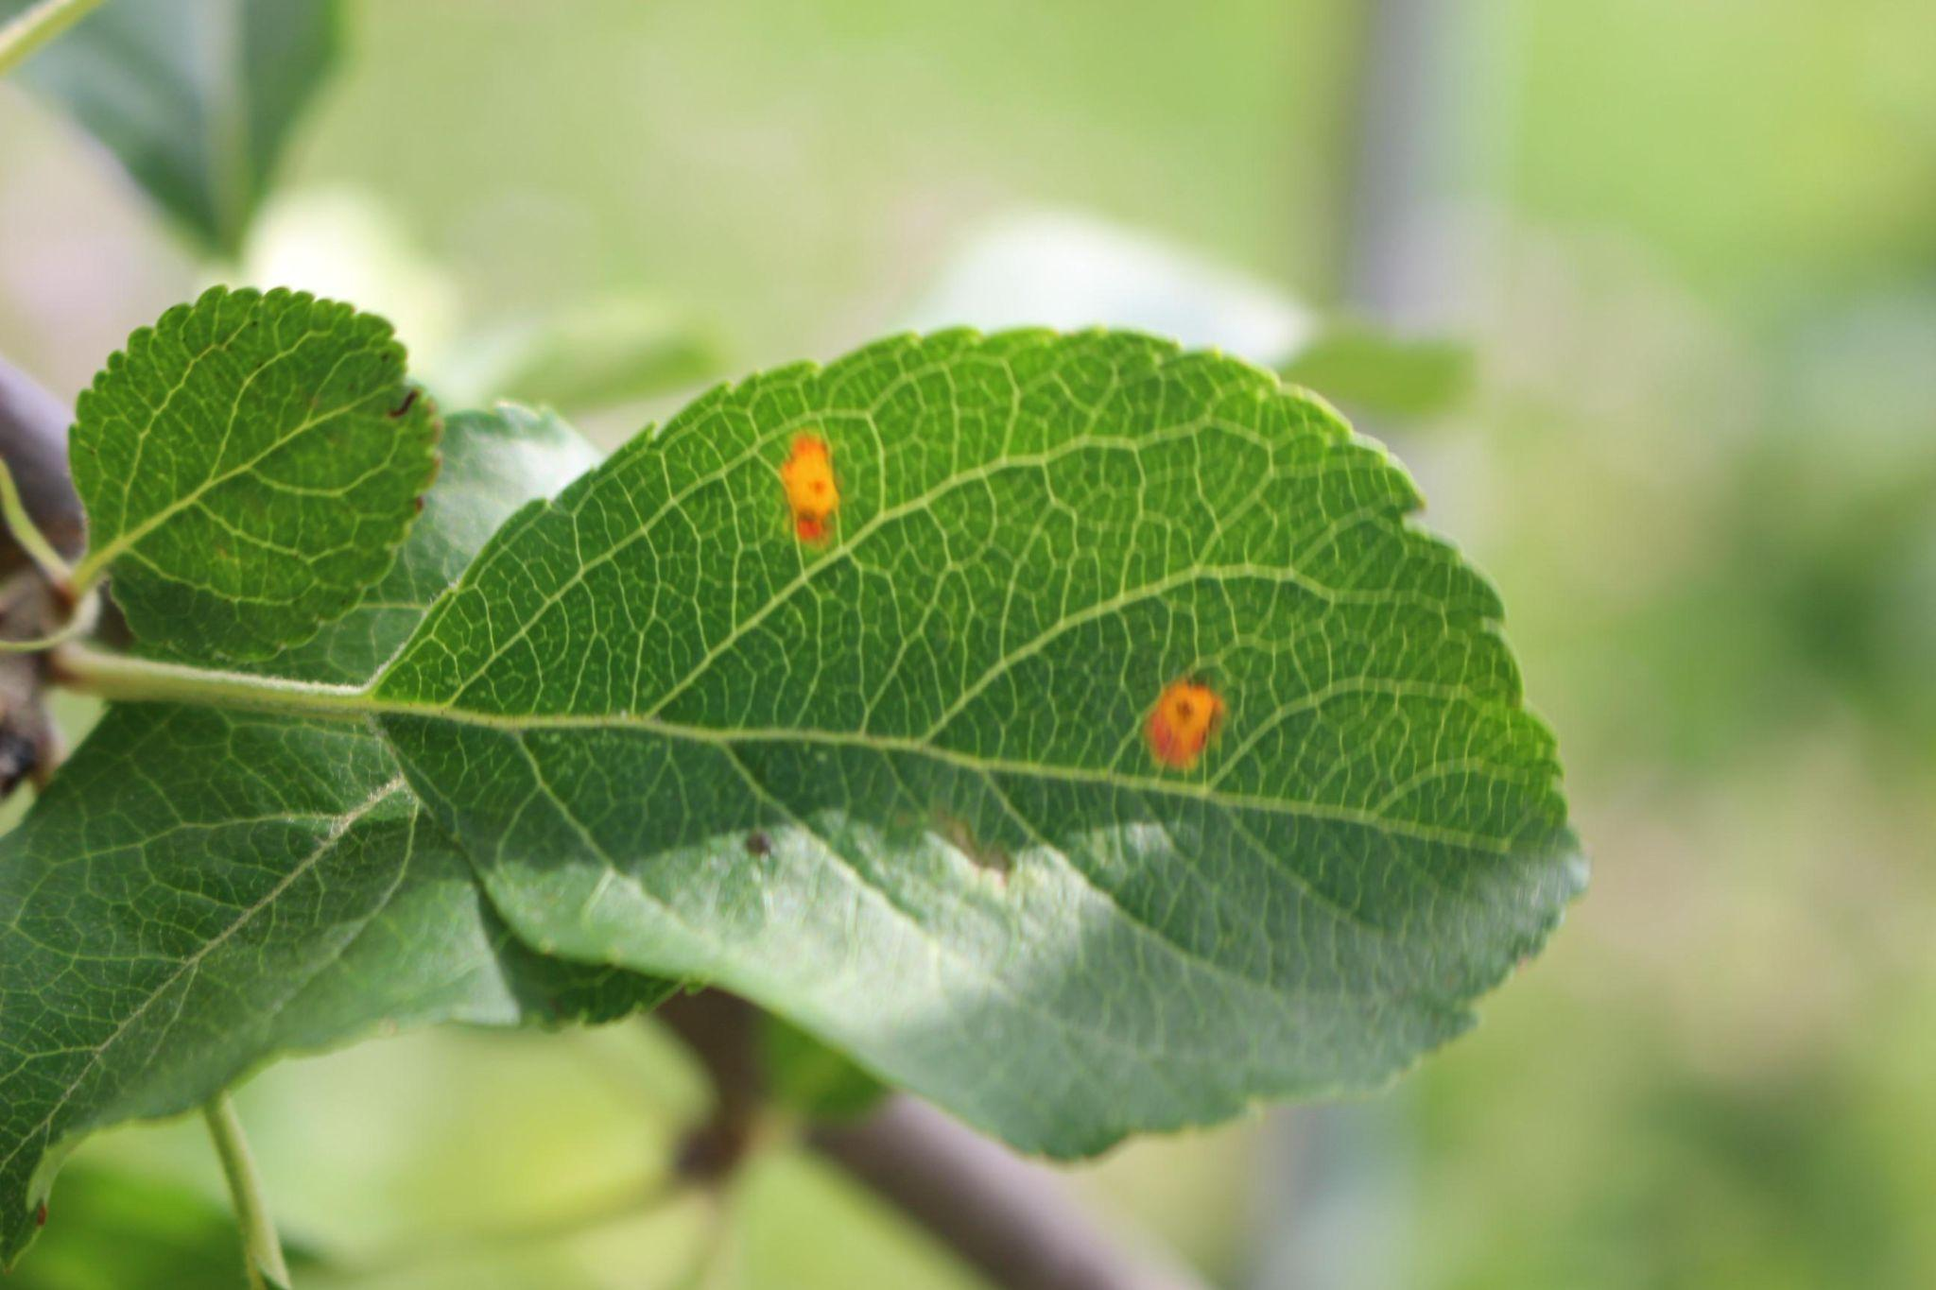

These datasets are the basis for multiple projects. Here are a few of the project's outcomes:

Project #1 : Convolutional Neural Network From Scratch^{[4]}

The model performed successfully, scoring 97.0% accuracy in label prediction for the validation dataset. It was also able to recognize relevant trends in all of the dataset's classes.

Project #2 : Plant Disease Recognition Using CNN Acc-95%^{[5]}

With train data, this model achieved over 90% accuracy, and with test data, it achieved about 88% accuracy. Additionally, the process made use of data augmentation techniques like flipping, rotating, zooming, and altering the contrast.

Methodology-General Architecture of the CNN
Due to our limited dataset and resources, we chose the AlexNet architecture for our convolutional neural network. We believe that this architecture is more suitable than other rapidly developing convolutional neural network algorithms. However, if the progress report shows that the model is not producing good predictions and that resources are insufficient, we will switch to the MobileNetV3 architecture as a backup plan.

In our first iteration, we obtained some results by adhering to the original AlexNet architecture (5 convolutional layers, 3 dense layers) described in the paper by Alex Krizhevsky, who developed AlexNet. Additionally, we started developing MobileNetV3 to compare performance and resource utilization.

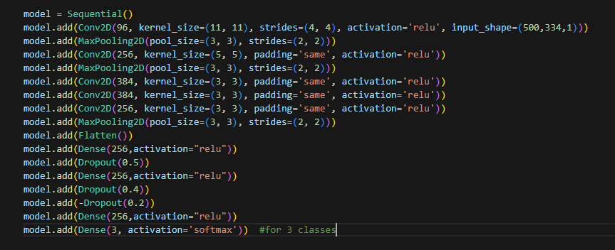
In all of the convolutional layers, we used the ReLU activation function, as used by Alex Krizhevsky himself and referenced in the papers he cites (in section "3.1 ReLU Nonlinearity"). We made this choice to reduce overfitting and to converge faster than tanh units. In the final layer, we have a sigmoid activation function and 3 neurons, as we will ultimately be making a prediction between only three labels.^{[6]}

Experimental Evaluation and Baseline Results
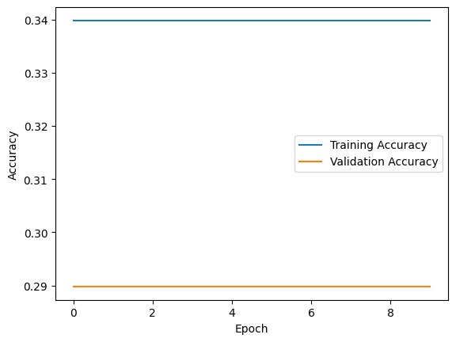
After resizing the images from 4000x2672x3 to 500x334x1 using OpenCV, we fed them directly to the model since our data did not need any train test split or any other pre-processing. The learning curve is attached.

As can be seen from the learning curve, our model is both overfitting and underperforming. Since the model produced the same poor predictions even with different epochs and batch sizes, we thought that the problem might be related to the kernel sizes. Therefore, we trained the model again as attached, with the kernel sizes larger than 3x3 to capture global details rather than small details like those in plant leaves.

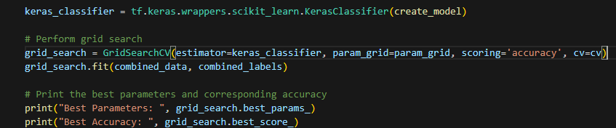
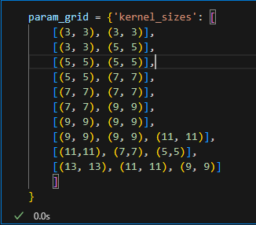
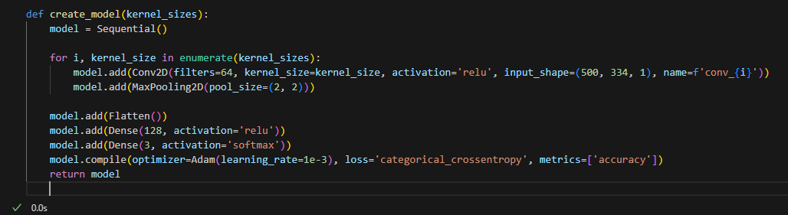
However, since the model continued to produce the same unchanging poor predictions, we have also learned that the problem is not related to the kernel sizes.

Our hypothesis is that the model does not have enough training data to be able to tune its parameters to obtain any kind of good result.

To address this issue, the first thing that will probably be tried in the later stages of the project is to expand the entire dataset again using data augmentation. Another hypothesis is that the model's kernels are not able to capture the small spots that are spread throughout the plant and indicate disease because the images are grayscale. Another thing that can be tried is to convert the images back to RGB and resize them to even smaller dimensions to reduce resource usage for the images that we will convert to RGB, and also to learn whether the hypothesis I mentioned in the previous sentence is correct.

References:
1.https://www.frontiersin.org/articles/10.3389/fpls.2021.731688/full

2.https://www.frontiersin.org/articles/10.3389/fpls.2016.01419/full

3.https://thejaps.org.pk/docs/Supplementary/v-25/07.pdf

4.https://www.kaggle.com/code/lusfernandotorres/convolutional-neural-network-from-scratch

5.https://www.kaggle.com/code/sunilthite/plant-disease-recognition-using-cnn-acc-95

6.Alex Krizhevsky, Ilya Sutskever, Geoffrey E. Hinton, ImageNet Classification with Deep Convolutional Neural Networks

